**PIZZA SALES SQL QUERIES**

1. **KPI’s Requirements**
   1. **Total Revenue**

SELECT SUM(total_price) AS total_revenue

FROM pizzasales;

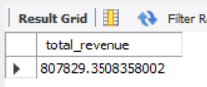

* 1. **Average Order Value**

SELECT ROUND(SUM(total_price)/COUNT(DISTINCT order_id), 2)

AS avg_order_value

FROM pizzasales;

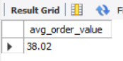

* 1. **Total Pizzas Sold**

SELECT SUM(quantity) AS total_pizzas_sold

FROM pizzasales;

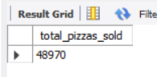

* 1. **Total Orders**

SELECT COUNT(DISTINCT order_id) AS total_orders_placed

FROM pizzasales;

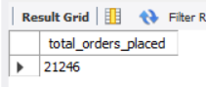

* 1. **Average Pizzas Per Order**

SELECT ROUND(SUM(quantity)/COUNT(DISTINCT order_id), 2)

AS avg_pizzas_per_order

FROM pizzasales;

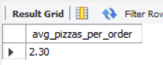

1. **Charts Requirement**
   1. **Daily Trends for Orders**

SELECT DAYNAME(order_date) AS order_day,

COUNT(DISTINCT order_id) AS total_orders

FROM pizzasales

GROUP BY order_day

ORDER BY CASE

WHEN order_day = 'Sunday' THEN 1

WHEN order_day = 'Monday' THEN 2

WHEN order_day = 'Tuesday' THEN 3

WHEN order_day = 'Wednesday' THEN 4

WHEN order_day = 'Thursday' THEN 5

WHEN order_day = 'Friday' THEN 6

WHEN order_day = 'Saturday' THEN 7

END ASC;

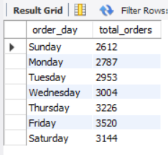

* 1. **Monthly Trends for Orders**

SELECT MONTHNAME(order_date) AS order_day,

COUNT(DISTINCT order_id) AS total_orders

FROM pizzasales

GROUP BY order_day

ORDER BY total_orders DESC;

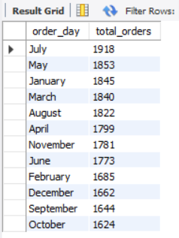

* 1. **Percentage Of Sales by Pizza Category**

SELECT pizza_category,

ROUND(SUM(total_price)*100/(SELECT SUM(total_price) FROM pizzasales) ,2) AS percent_sales

FROM pizzasales

GROUP BY pizza_category

ORDER BY percent_sales DESC;

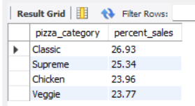

* 1. **Percentage Of Sales by Pizza Size**

SELECT pizza_size,

ROUND(SUM(total_price)*100/(SELECT SUM(total_price) FROM pizzasales) ,2) AS percent_sales

FROM pizzasales

GROUP BY pizza_size

ORDER BY percent_sales DESC;

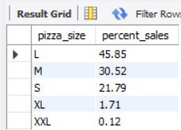

* 1. **Total Pizzas Sold by Pizza Category**

SELECT pizza_category,

SUM(quantity) AS Total_sold

FROM pizzasales

GROUP BY pizza_category

ORDER BY Total_sold DESC;

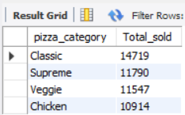

* 1. **Top 5 Best Sellers by Total Pizzas Sold**

SELECT pizza_name,

SUM(total_price) AS total_revenue

FROM pizzasales

GROUP BY pizza_name

ORDER BY Total_revenue DESC

LIMIT 5;

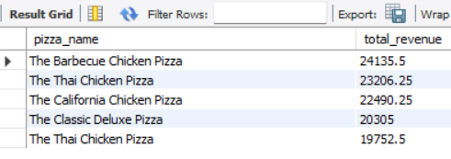

* 1. **Top 5 Least Popular Pizzas by Total Sales**

SELECT pizza_name,

SUM(total_price) AS total_revenue

FROM pizzasales

GROUP BY pizza_name

ORDER BY Total_revenue

LIMIT 5;

